Business Impact Model

Structure:-
Section 1 — Problem Size

Metric | Value | Source
Demat accounts in India | 14 crore+ | SEBI 2024
Retail investors with no financial plan | 95% | AMFI survey
Average expense ratio overpaid | 1.2% vs 0.5% direct | Morningstar
Annual SEBI-registered advisor fee | ₹25,000+ | Industry avg
Indians filing ITR missing deductions | ~60% | ClearTax report

Section 2 — WealthLens Impact per User

Feature | What it finds | Annual Saving per user
Expense ratio optimization | Switch regular → direct plans | ₹8,000–₹18,000
Tax deduction identification | 80C, 80D, NPS gaps | ₹15,000–₹67,500
Tax regime optimization | Old vs new regime switch | ₹10,000–₹30,000
Overlap elimination | Consolidate duplicate funds | ₹3,000–₹8,000 in saved fees
Total per user |  | ₹36,000–₹1,23,500/year

Section 3 — Scale Math

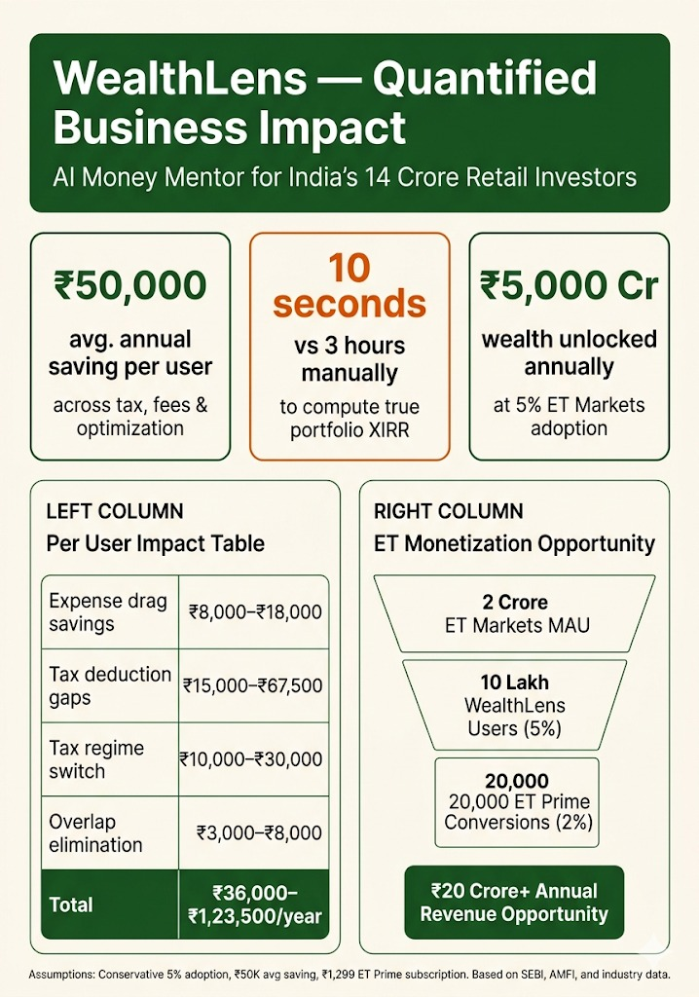
Section 4 — Time Saved

Task | Manual Time | WealthLens Time | Saving
Portfolio XIRR calculation | 2-3 hours in Excel | 10 seconds | 99.9%
Tax regime comparison | 1-2 hours with CA | 30 seconds | 99.9%
Overlap analysis across funds | Not possible manually | Instant | 100% new capability
Couple's joint optimization | ₹5,000 CA consultation | Free, instant | 100% cost saving

